Wire Loop Alarm

Author | Views | Views Today | Rank | Comments
Alex Meaden | 23,441 | 43 |  | 19

This circuit is a simple wire loop alarm that can be used in doorways, hallways, or any other place the tripwire will be broken by intruders. The circuit has a built in siren, but it can be replaced by a relay to drive an external siren, commercial alarm, etc.

Schematic
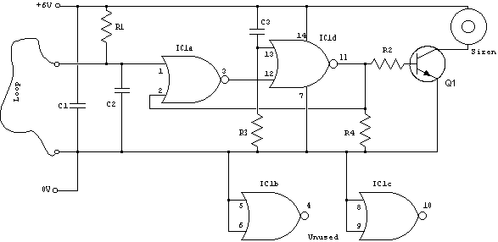

Parts

Part | Total Qty. | Description | Substitutions
R1 | 1 | 100K 1/2W 1% Resistor
R2, R4 | 2 | 10K 1/2W 1% Resistor
R3 | 1 | 1 Meg 1/2W 1% Resistor
C1, C3 | 2 | 0.1uF Ceramic Disc Capacitor
C2 | 1 | 0.01uF Ceramic Disc Capacitor
IC1 | 1 | 4001UBE Quad 2-i/p NOR Gate
Q1 | 1 | MPSA14 Low Power NPN Transistor
SIREN | 1 | Micro piezo siren 12V DC 150mA, 110dB @ 1M
LOOP | 1 | See "Notes"
MISC | 1 | Board, Wire, Socket For IC1

Notes
- Email Alex Meaden with questions, comments, etc.
- The loop can be any type of hookup wire, with a maximum resistance of about 90K. Using very thin wire (40AWG, for example) will make a very sensitive trip wire, but will shorten the distance it can be strung due to the high resistance.
- The siren can be replaced with a relay to drive external loads.

