The circuit is very simple and inexpensive. This is good thing because most commercial stepper motor controller ICs are quite expensive. This circuit is built from standard components and can easily be adapted to be controlled by a computer. If you use cheap surplus transistors and stepper motor, the price of the circuit can be kept to under $10.

Schematic
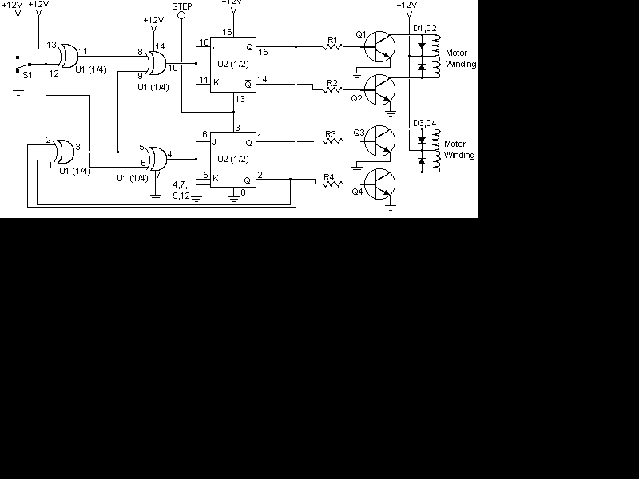

Parts

Part | Total Qty. | Description | Substitutions
R1, R2 ,R3, R4 | 4 | 1K 1/4W Resistor
D1, D2, D3, D4 | 4 | 1N4002 Silicon Diode
Q1, Q2, Q3, Q4 | 4 | TIP31 NPN Transistor (See Notes) | TIP41, 2N3055
U1 | 1 | 4070 CMOS XOR Integrated Circuit
U2 | 1 | 4027 CMOS Flip-Flop
S1 | 1 | SPDT Switch
MISC | 1 | Case, Board, Wire, Stepper Motor

- Q1-Q4.
- Every time the STEP line is pulsed, the motor moves one step.
- S1 changes the motors direction.

