LED or Lamp Flasher

Minimum parts counting
Designed for 3V battery operation
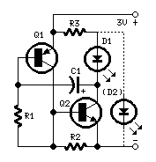
Parts:
R1_______33K 1/4W Resistor
R2,R3____47R 1/4W Resistors

C1_______10΅F 25V Electrolytic Capacitor

D1,(D2)__LED(s) (Any type and color)

Q1_____BC560 45V 100mA PNP Transistor
Q2_____BC337 45V 800mA NPN Transistor

Notes:
- Power supply can vary from 2 to 4.5V.
- Add D2 to obtain two LED alternate blinking.
- D1's on-time is shorter than off-time. The opposite regarding D2.
- You can also use D2 only, shorting D1.
- Don't change resistors' values.
- Flashing frequency can be varied changing C1 value from 2.2΅F to 100΅F and higher.
- This circuit is very efficient when driving a 3.2V lamp. In this case omit the LEDs and R3, connecting the lamp at Q2's collector and to positive supply, further reducing parts counting.

