Fancontrol

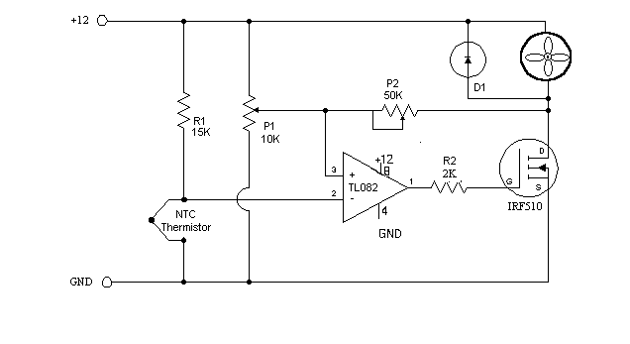
This is a simple circuit that will do what you want I believe.
R1 15k ohm resistor
NTC Thermistor- 10k ohm, sold at Radio Shack in the states.
P1 10k ohm potentiometer - sets the low speed(voltage) of the fans at the cool temperature. P2 50K ohm potentiometer - sets the gain of the circuit - how fast the voltage will rise to full output when the temp is higher. TL082 a op-amp that I had handy, most any single voltage op-amp should work. The TL082 is a dual op-amp if you want more then one controller on a board. note that the power and ground connections for the op-amp are not shown on the schematic. R2 - The TL082 is a fast op-amp, needed R2 to reduce oscillation. IRF-510 A 4 amp mos-fet in a TO-220 case. Bascially as the voltage on the gate rises the mos-fet will conduct more current. note 1 there are also IRF-520 and 530 versions that will handle more current. note 2 Even at 5 watts the mos-fet will disapate some heat and will need to be heat-sinked or at least in the air flow path. the large metal part of the fet will be at drain(D) voltage level. Do not attach to case. D1, almost any diode, 1N4001 should work,it conducts back around the fan when the mos-fet turns off. As the fan continues spinning it will produce a voltage on the drain lead of the fet. D1 will limit that voltage. Adjustment, easiest if you have a voltmeter but can be done without. Get the thermistor at room temp. Adjust P1 for the low speed that you want your fans to run at. Heat the thermistor to the high temp you want the fans at full speed. ( I stuck it under my tongue) Adjust P2 until the fans are at full speed( with voltmeter the highest voltage you can get) then adjust P2 until the speed/voltage just begins to drop off. Most fan specs that I have seen show a low voltage limit of around 7 volts. Some of the smaller 80mm fans have a lower limit of 8 volts. If you set the low voltage to low the fans may stall until the thermistor heats up enough. Let me know if you build this circuit and how it works for you. corrected, single voltage op-amps should be used, OP-07 is a dual voltage

