DC Motor Control Circuit
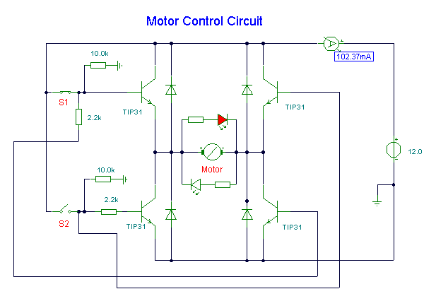
Notes:
Here, S1 and S2 are normally open , push to close, press button switches. The diodes can be red or green and are there only to indicate direction. You may need to alter the TIP31 transistors depending on the motor being used. Remember, running under load draws more current. This circuit was built to operate a small motor used for opening and closing a pair of curtains. As an advantage over automatic closing and opening systems, you have control of how much, or how little light to let into a room. The four diodes surriunding the motor, are back EMF diodes. They are chosen to suit the motor. For a 12V motor drawing 1amp under load, I use 1N4001 diodes.

