Black Light
This circuit is a simple ultraviolate light that can be powered by a 6 volt battery or power supply that is capable of supplying 1 or more amps.

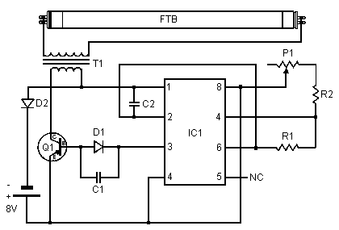
Theoritical Diagramm
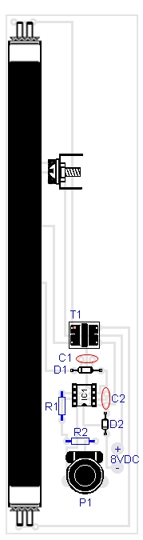 | 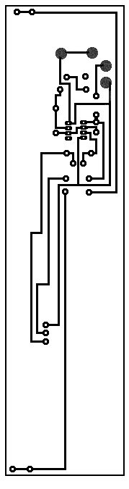
PARTS
Part | Total Qty. | Description
C1 | 1 | 0.0047uf Mono Capacitor
C2 | 1 | 0.1uf Disc Capacitor
D1, D2 | 2 | 1N4007 Diode
FTB | 1 | Filtered Blacklight Tube
IC1 | 1 | 555 Timer IC
P1 | 1 | 10k Trim Pot
Q1 | 1 | TIP30 PNP Power Transistor
R1 | 1 | 470 Ohm Resistor
R2 | 1 | 270 Ohm Resistor
T1 | 1 | Medium Yellow Inverter Transformer
MISC | 1 | IC Socket, Heat Sink For Q1, Screw, Nut, Wire and PC Board

Notes:
1. P1 changes brightness of the black light tube.

