This simple circuit uses an incandescent lamp to detect airflow. With the filament exposed to air, a constant current source is used to slightly heat the filament. As it is heated, the resistance increases. As air flows over the filament it cools down, thus lowering it's resistance. A comparator is used to detect this difference and light an LED. With a few changes, the circuit can be connected to a meter or ADC to provide an estimation on the amount of air flow.

Schematic
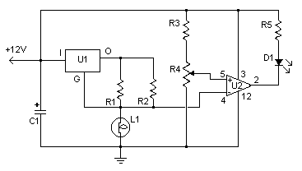

Parts

Part | Total Qty. | Description | Substitutions
R1 | 1 | 100 Ohm 1/4W Resistor
R2 | 1 | 470 Ohm 1/4W Resistor
R3 | 1 | 10k 1/4W Resistor
R4 | 1 | 100K 1/4W Resistor
R5 | 1 | 1K 1/4W Resistor
C1 | 1 | 47uF Electrolytic Capacitor
U1 | 1 | 78L05 Voltage Regulator
U2 | 1 | LM339 Op Amp
L1 | 1 | #47 Incandescent lamp with glass removed (See "Notes")
D1 | 1 | LED
MISC | 1 | Board, Wire, Sockets for ICs, etc.

Notes
- The glass will have to be removed from L1 without breaking the filament. Wrap the glass in masking tape and it in a vise. Slowly crank down until the glass breaks, then remove the bulb and carefully peel back the tape. If the filament has broken, you will need another lamp.

