Adjustable Strobe Light
This one uses a much more powerful "horse shoe" Xenon tube which produces more light. You can also control the flash rate up to about 20Hz. Do not look directly at the flash tube when this thing is on!

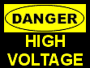

Schematic
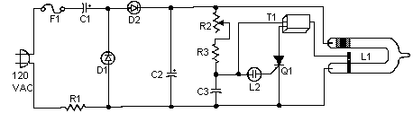

PC Board Layout


Parts Placement
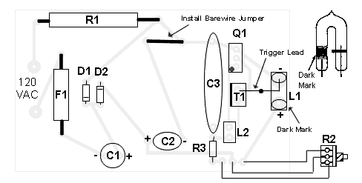

Parts
R1 | 250 Ohm 10 Watt Resistor
R2 | 500K Pot
R3 | 680K 1/4 Watt Resistor
D1,D2 | 1N4004 Silicon Diode
C1, C2 | 22 uF 350V Capacitor
C3 | 0.47uF 400 Volt Mylar Capacitor
T1 | 4KV Trigger Transformer (see "Notes")
L1 | Flash Tube (see "Notes")
L2 | Neon Bulb
Q1 | 106 SCR
F1 | 115V 1A Fuse
Misc | Case, Wire, Line Cord, Knob For R2

Notes
1. T1 and L1 are available from The Electronics Goldmine
2. This ciruits is NOT isolated from ground. Use caution when operating without a case. A case is required for normal operation. Do not touch any part of the circuit with the case open or not installed.
3. Most any diodes rated at greater then 250 volts at 1 amp can be used instead of the 1N4004's.
4. Do not operate this circuit at high flash rates for more than about 30 seconds or else C1 and C2 will overheat and explode.
5. There is no on/off switch in the schematic, but you can of course add one.

